**NOAA Ship THOMAS JEFFERSON Procedure Document**

Procedure:

**SSS Certification**

Creation Date:

08/27/2020

Revision Date:

04/04/2022

Software used:

SonarPro, Discover, Hypack, Caris

Procedure Number:

**TBD**

Approved:

**TBD**

# Overview and Scope

To help with side scan cert for HSRR.

# Procedure Inputs and Outputs

## Inputs:

.SDF, .000

## Outputs:

.xlsx

# Procedure

**SSS Certification**

As per the FPM, survey lines are to be run in alternating directions and at survey speed as shown below. This is so you can ensonify the feature with each channel of the side scan. You need to run multibeam over the feature so you know exactly where this feature is. Running multibeam over the feature and processing the data to know where it is before line planning is the best method to conduct a side scan cert. The distance from the target for the first set of lines will be 15% of the range scale. The distance to the second set of lines from the target will be 50% of the range scale. The third set will be 85% of the range scale. A mirrored set of lines must be run orthogonal to the first 3 sets (see example below).

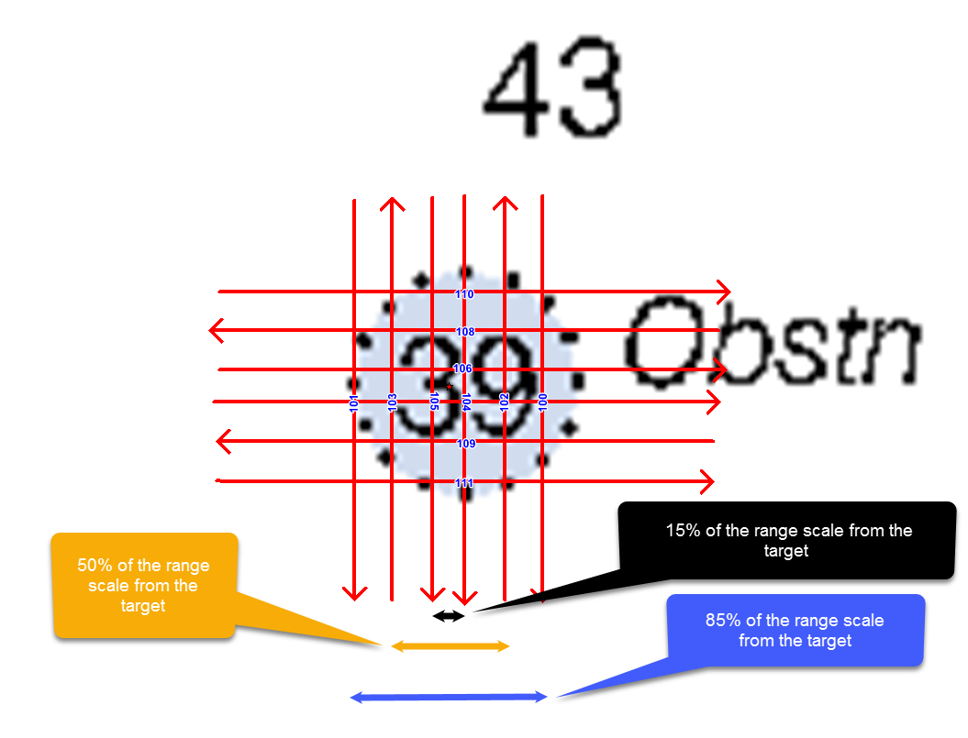

**Processing**

Process the side scan data as you normally would. You need to go through each line and place a contact over the same feature. After all your side scan contacts are placed you need to fill out the side scan cert excel sheet found at "K:\Standard_Operating_Procedures\05_HSRR\Reference Files\Vessel_SSS_Certification_XXmRS.xlsx"

Do not adjust or delete cells within the spreadsheet. You will break formulas or delete the Chi Squad table on the right.

The only cells you need to fill out or adjust within the spreadsheet are the orange background cells.

Fill in the Vessel, range scale, and day number at the top of the spreadsheet.

Fill in the Lat and Long in decimal format of the designated sounding of the feature from the MBES under MBES Position of Contact.

You need to fill in the Lat, Long, and Line heading of the contact in the orange cells under the SSS contact table. Lat and Long is in the decimal format as well. Make sure that the Line heading is the heading of the actual line that contains that specific contact. You do not want to have a line heading for a contact that is not actually within that line.

You need to adjust the Distance Error Limit (meters) depending on if you are certing a towed system or a hull mounted system. For towed systems you need to put in 10. If it is a hull mounted system you need to put in 5.

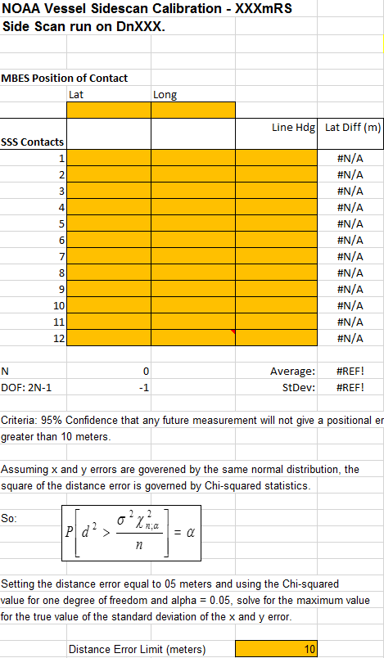

In the green box below it will tell you whether or not you pass or failed. The one you want to pass is the first method. FPM and alternate FPM methods are not as accurate as the first method.

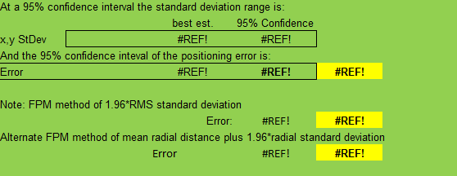

If the cert fails you will need to adjust the Layback error within the HVF. It is okay to fail one method. More than one then you need to make adjustments. You should adjust the HVF within the VesselConfig folder of the project. I would adjust it by 1m in either direction to start to see how it affects the contact position.

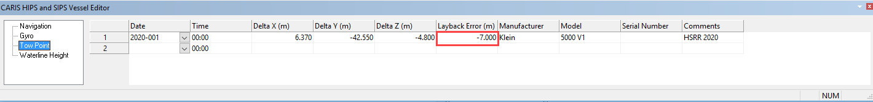

After you make an adjustment you need to recompute Towfish Navigation and then Contact Positions. Do not use the check box for contact position under towfish Navigation in Caris 11. To make both of these options available you need to have your track lines selected under the Active Track Lines tab in Caris 11.

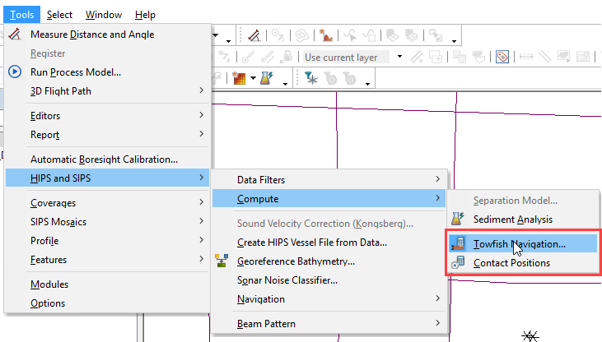

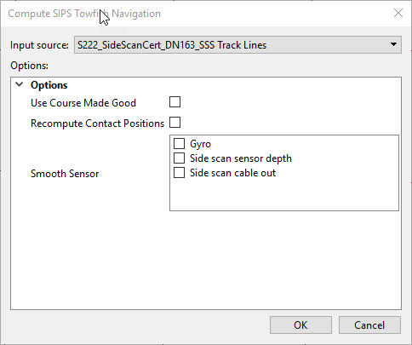

Use the settings for Compute Towfish Navigation as seen above. Do not select Recompute Contact Positions. You must use the stand alone option to recompute the contact posion.

After you are done you need to update your spreadsheet and see if you pass. Keep making adjustments to the Layback error until you pass and your contacts are in general agreement of the location of the feature.

# References

"K:\Standard_Operating_Procedures\05_HSRR\Reference Files\Vessel_SSS_Certification_XXmRS.xlsx"